Brian Rodgers Vargo

CSE 270 Final Project

Binary Addition Simulation

Demonstration of Functionality

Core Idea: Create a way to simulate a binary adder

* Allow users to use gates and connections to create a binary adder
* Help users to learn the process of creating such a circuit with visual feedback (Seeing what happens when turning off and on different inputs)

Outline:

1. Placing connections  *(p.2)*
2. Placing gate  *(p.2)*
3. Modifying input status  *(p.3)*
4. Multiple links  *(p.3)*
5. Mapping Inputs to Outputs  *(p.4)*
6. Truth Table Verification *(p.4)*
7. A Valid Binary Adder example  *(p.5)*

Features:

1. **Place new connections**

* Connections may start on an input or on a gate

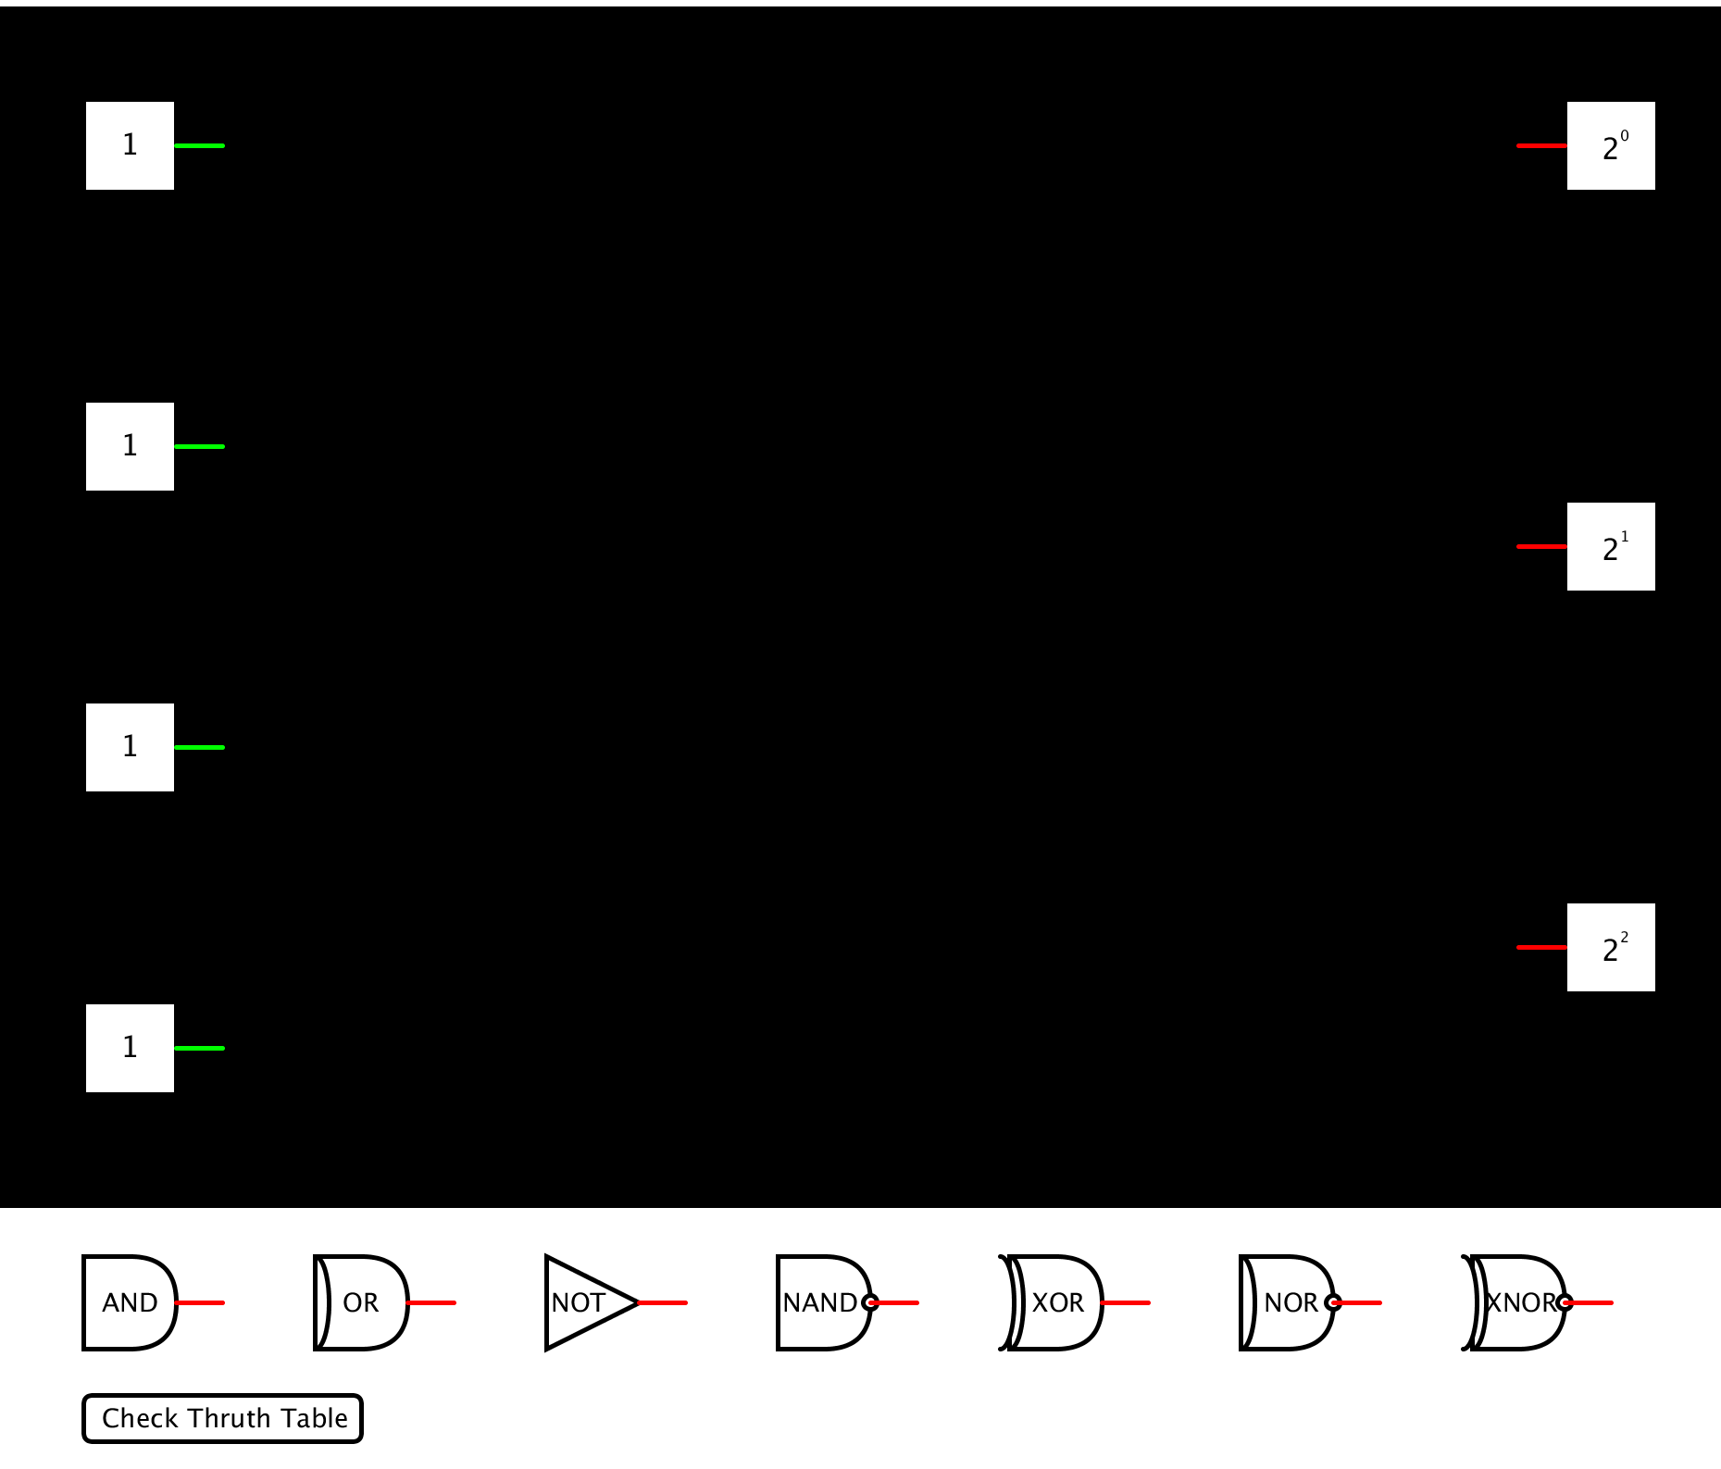 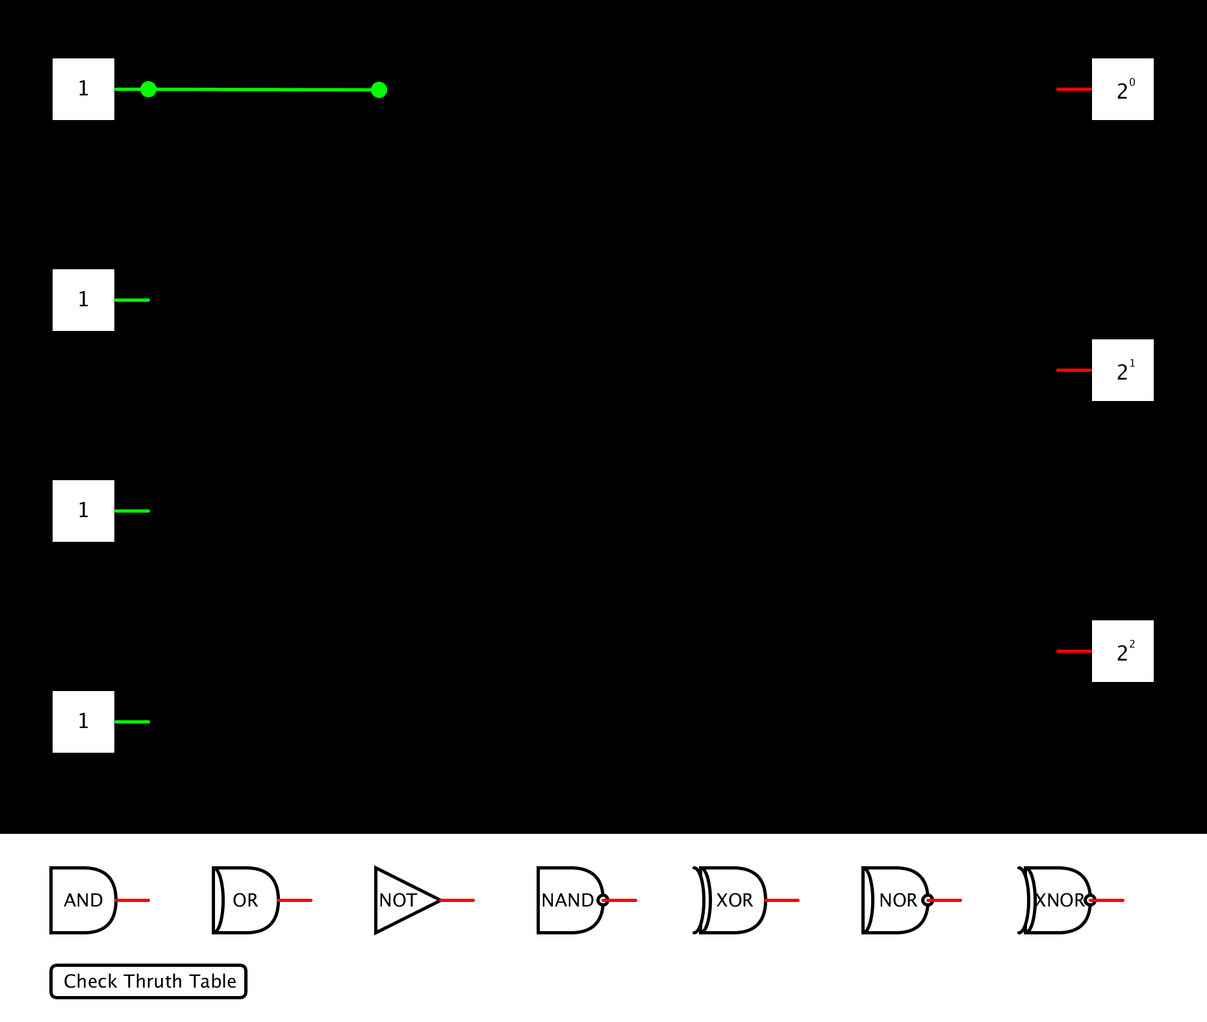

Here we can see the result of click on an input and placing a ‘connection’

*Note: We can add points to an existing connection by clicking on it’s endpoint

1. **Placing a gate**

* Select a gate to add simply by dragging it where ever you would like

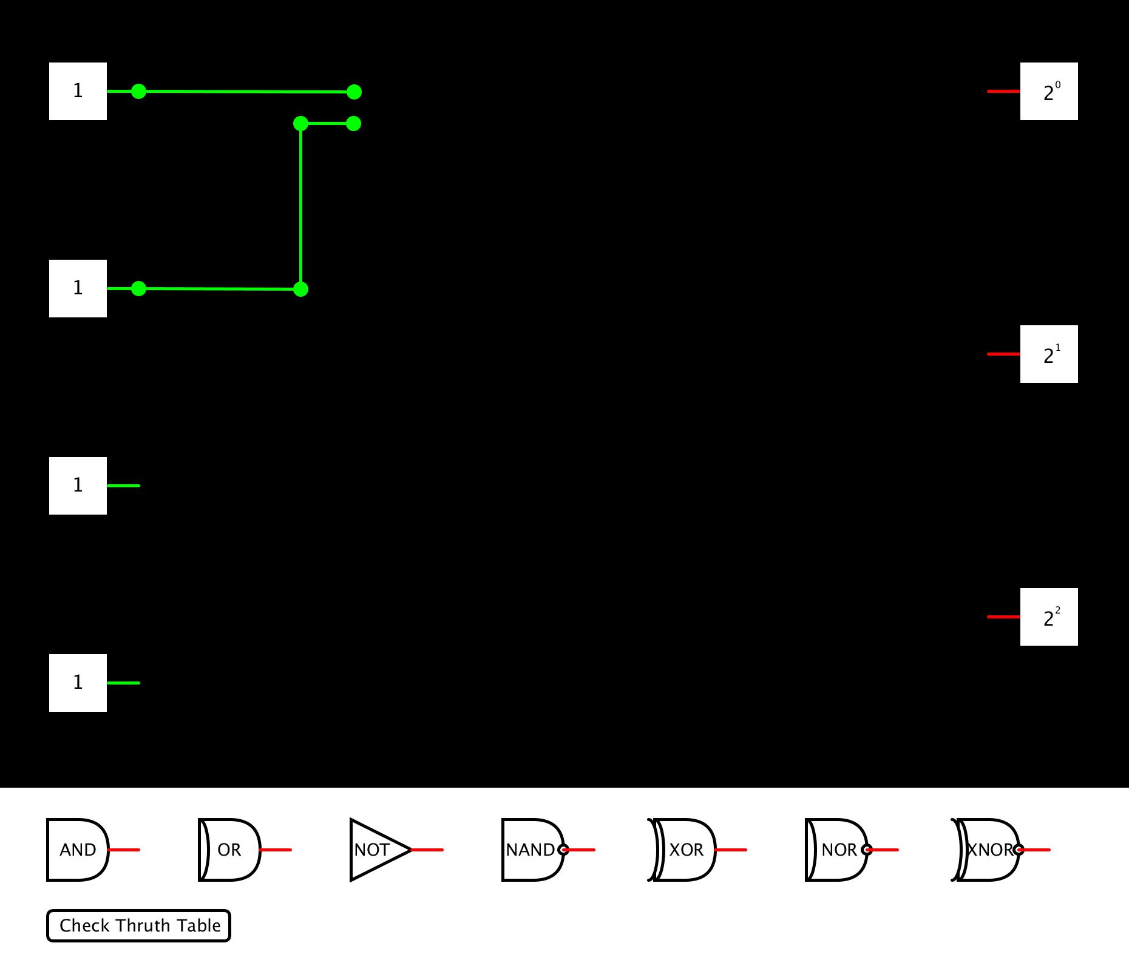 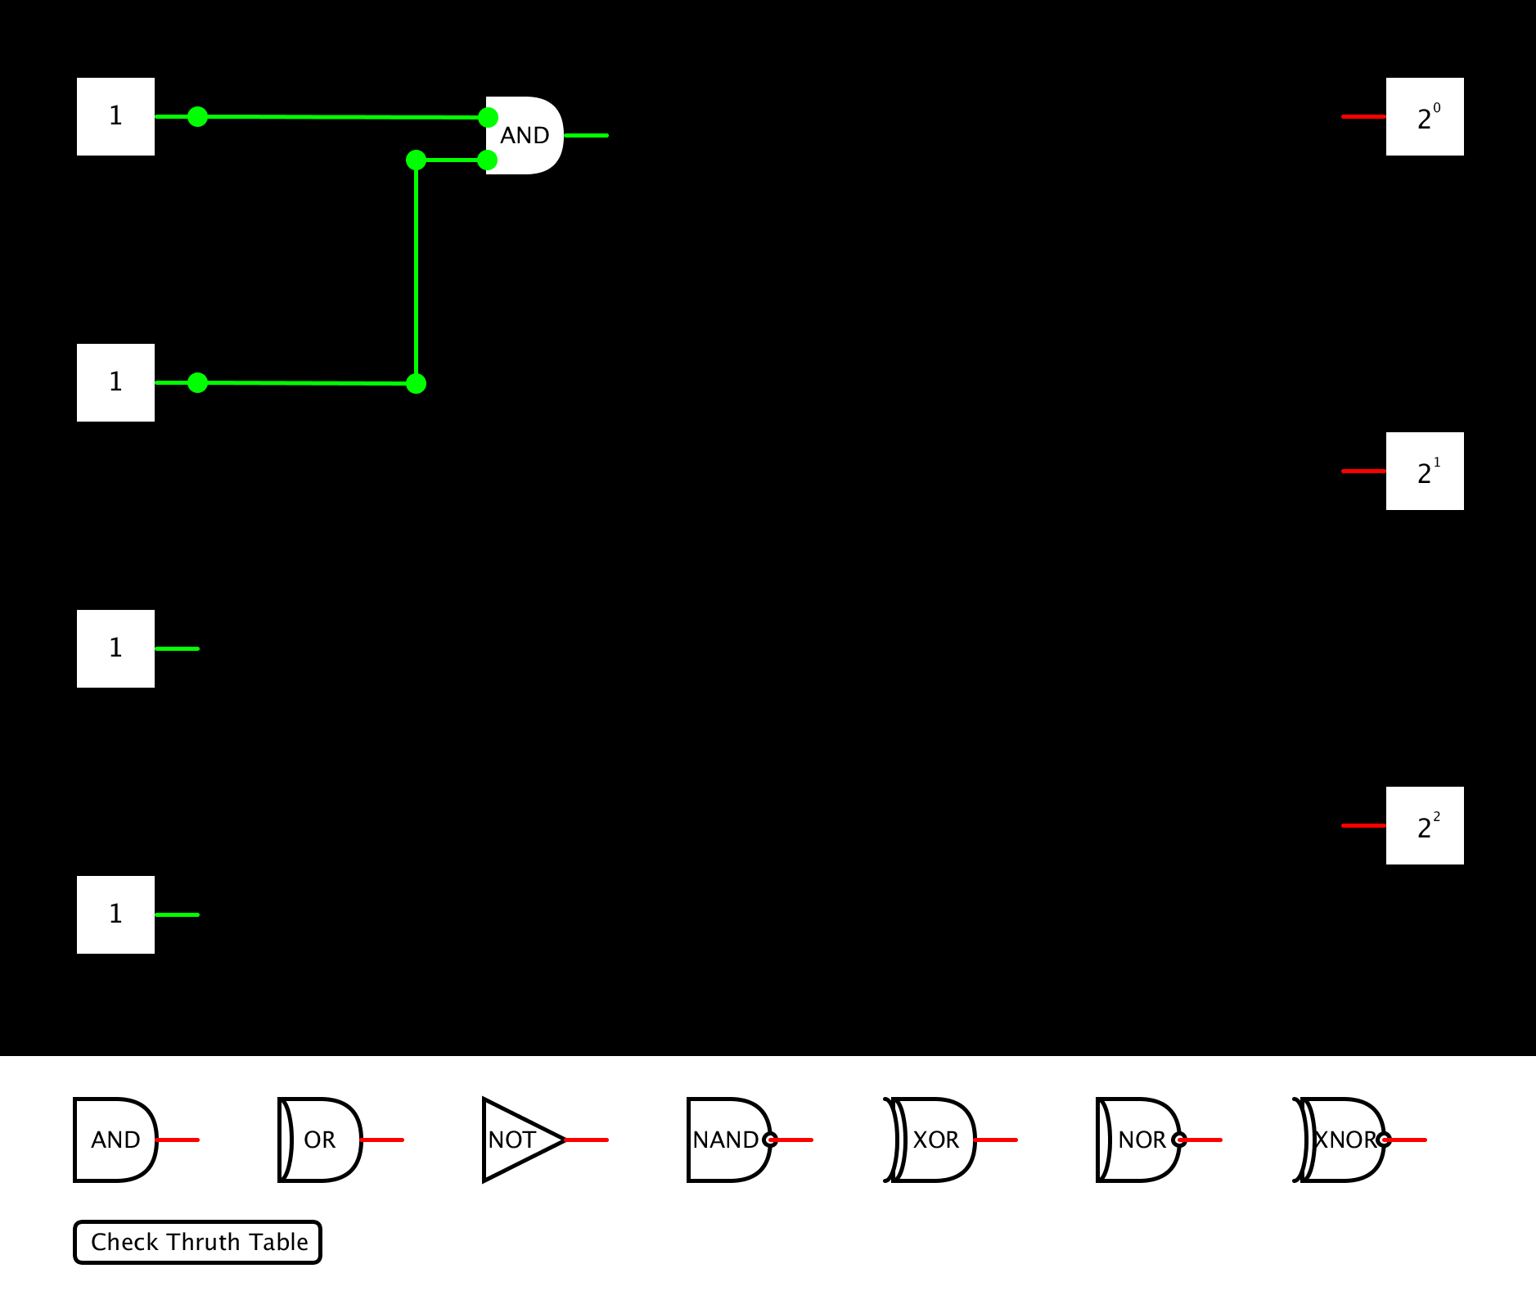

Notice, we have added a new connection as well as an AND gate to link them.

1. **Changing an input’s status**

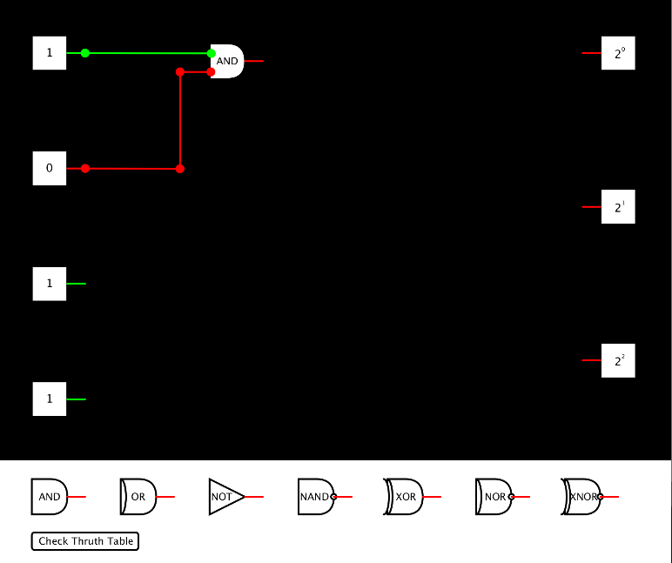

By clicking on an input box (labeled with a 1 or 0), we change the status of that input.

1. **Multiple links**

* Below, we create an additional and gate and link the two together….

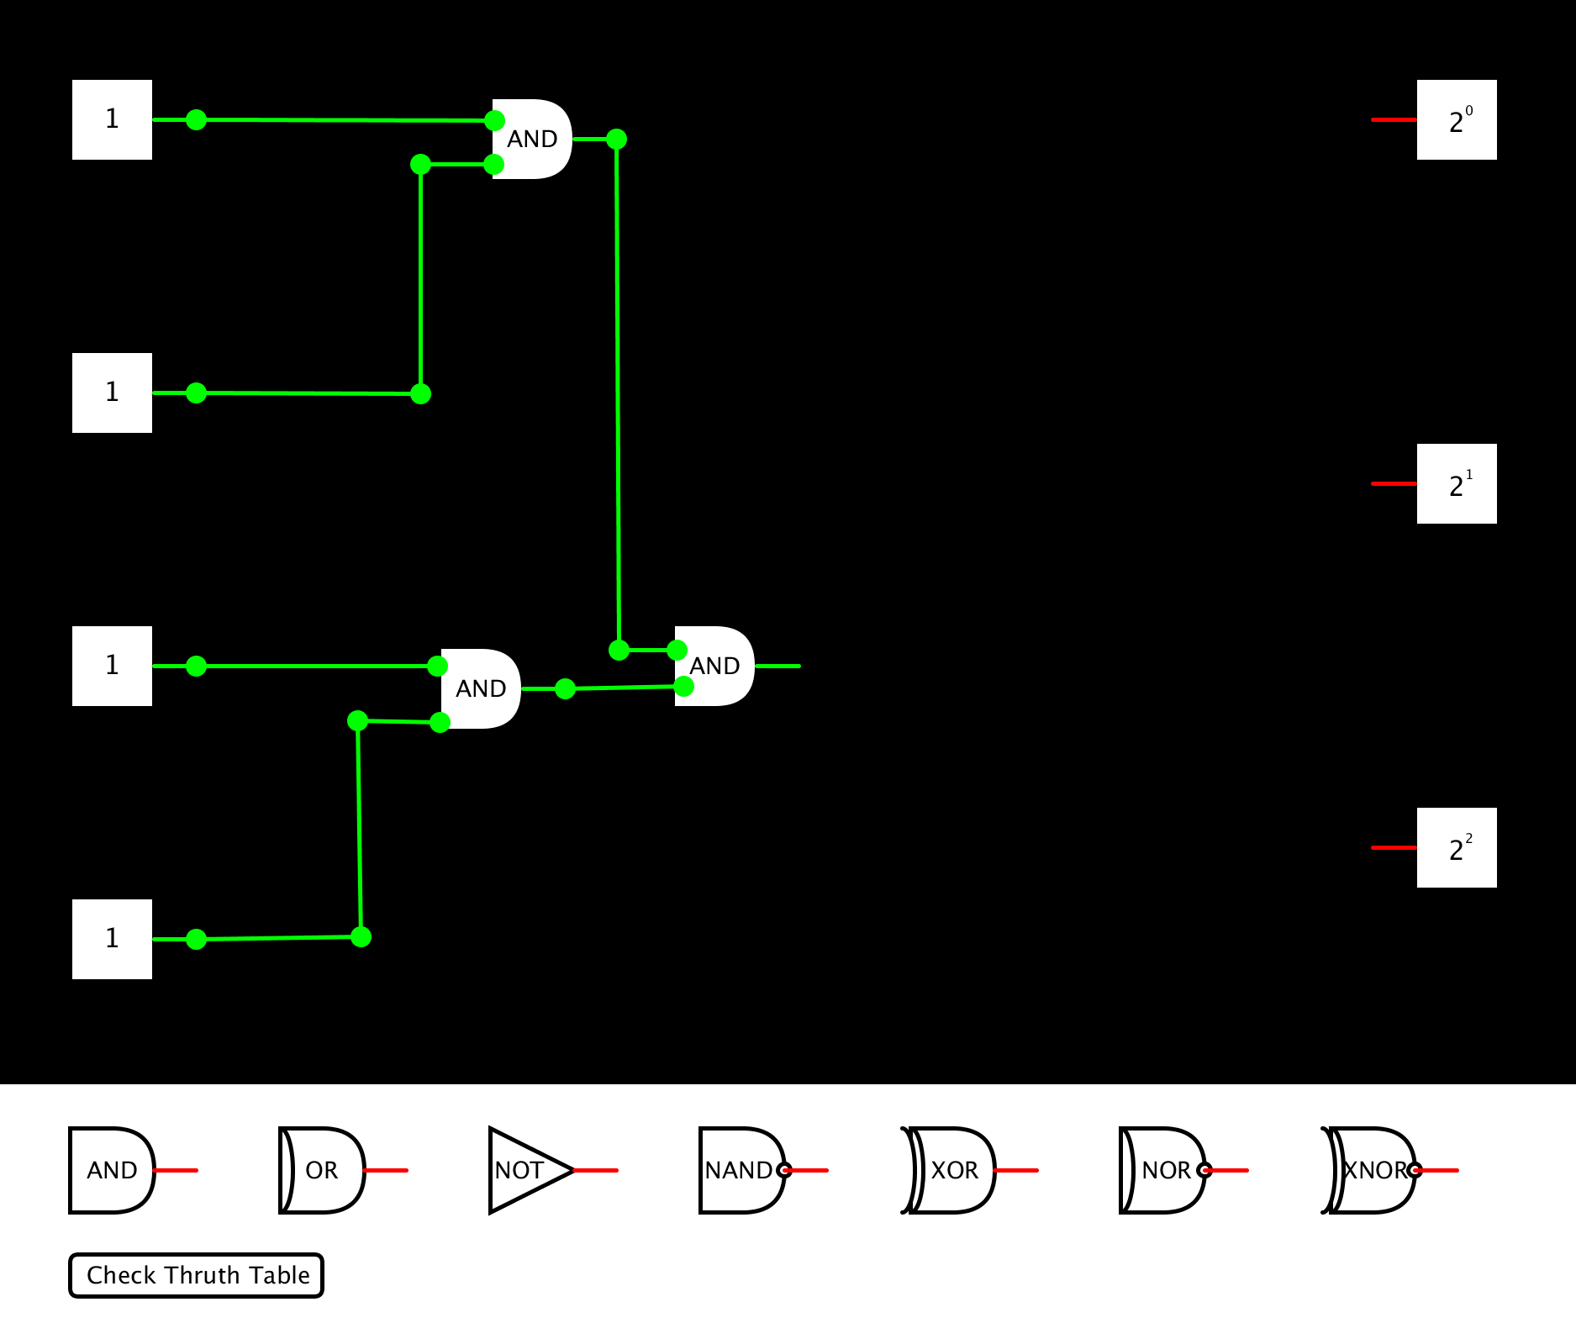 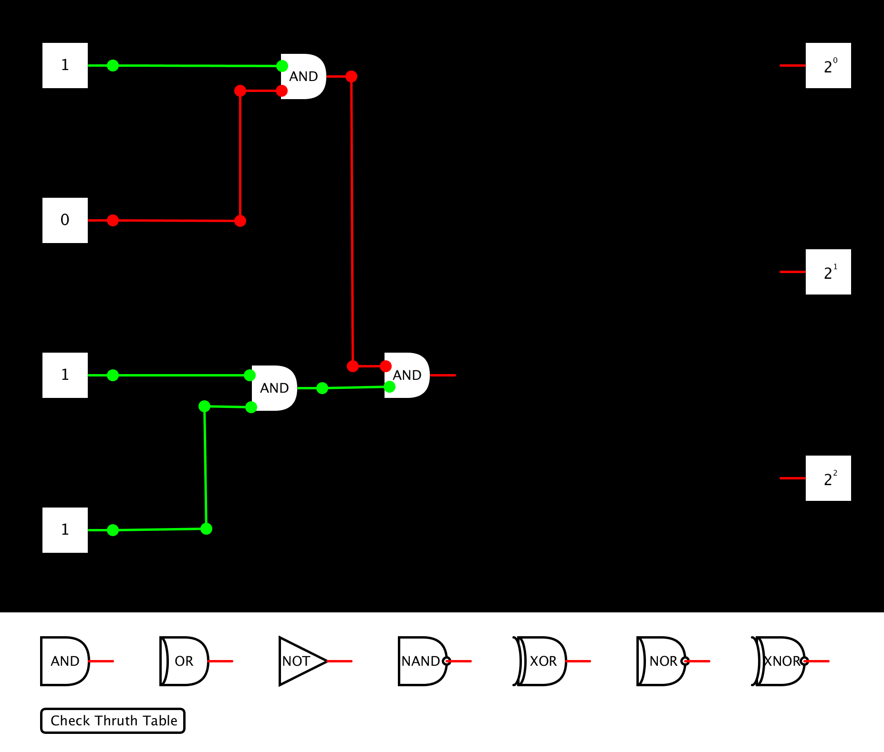

Note the change of input 2’s status and its effect on the final AND gate

1. **Mapping inputs to outputs**

* As the final goal here is to create a valid binary adder, we must have some way to express the sum of the outputs.

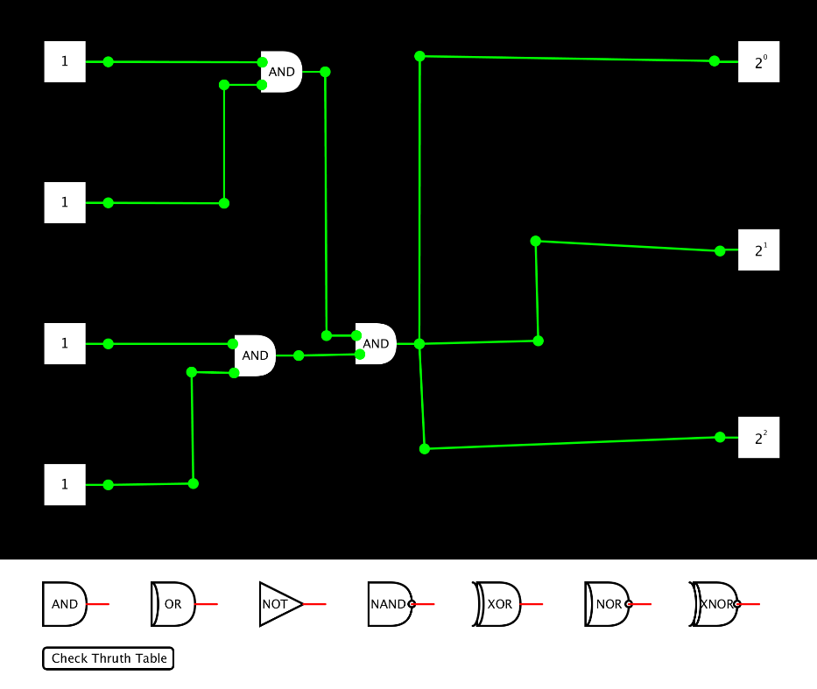

While this is not a valid binary adder, notice how connection are draw to the outputs. This is done simply by dragging the connection to the output and placing it.

1. **Truth Values**

* In order to verify the validity of our binary adder, the button ‘Check Truth Table’ will display the truth values for the circuit and check if every possibility of input states is correct.
* E.g. The combination of inputs 1, 1, 1, 1, should output $2^{2}$, because 1+1+1+1 = 4, or 100 in binary.

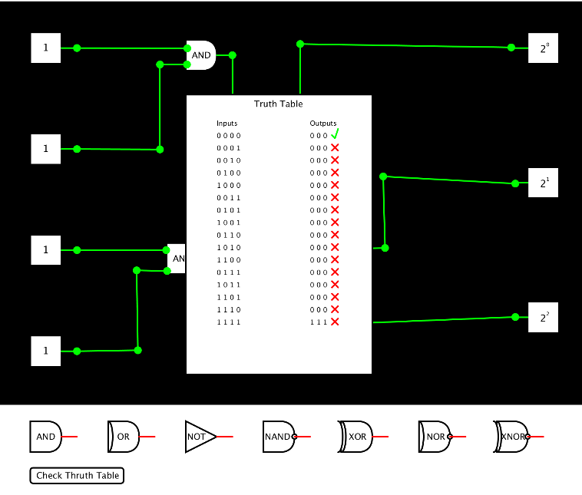

The truth table here shows that our circuit is not valid for any combination of inputs other that 0,0,0,0.

1. **A correct binary adder example**

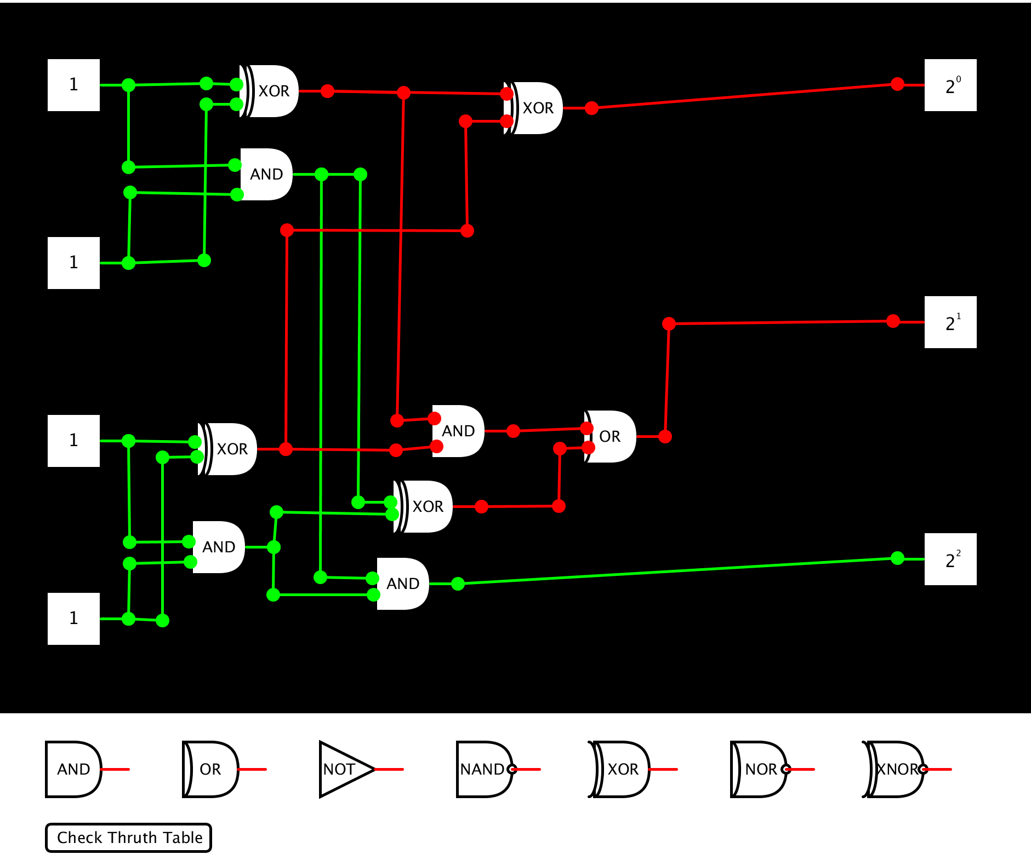 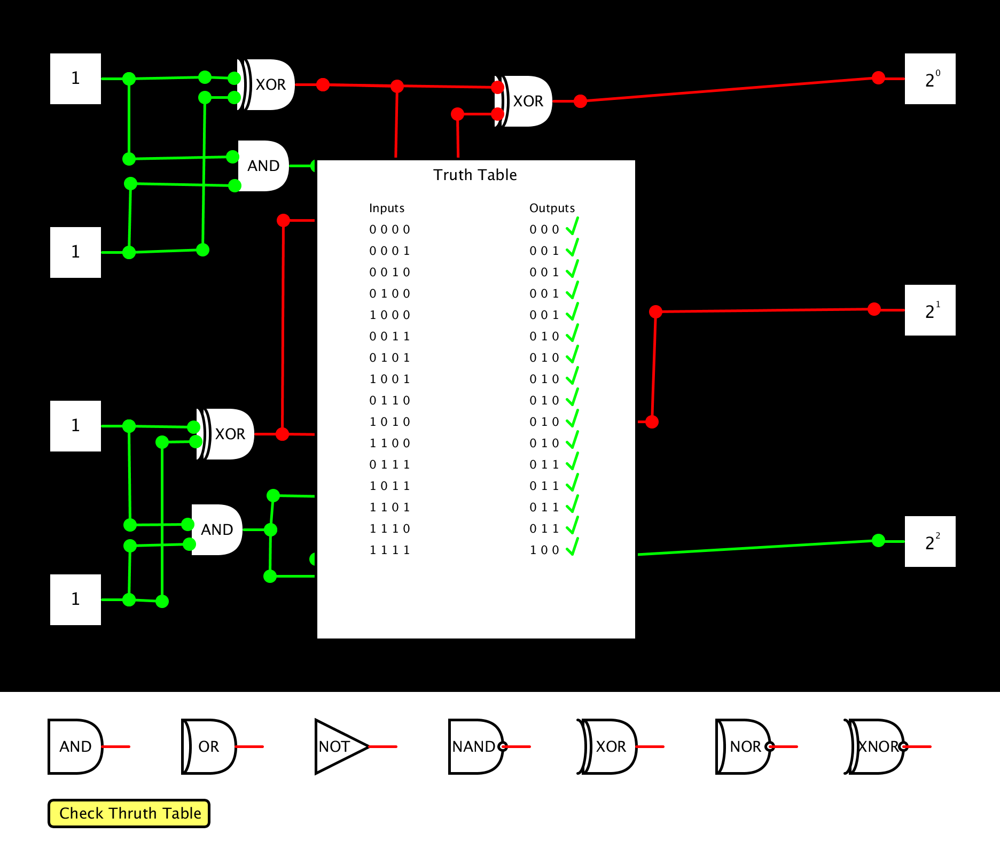

Left: Valid Binary Adder Right: Corresponding Truth Table

* By modifying the circuit into an intentionally incorrect state, we can see how the truth table changes…

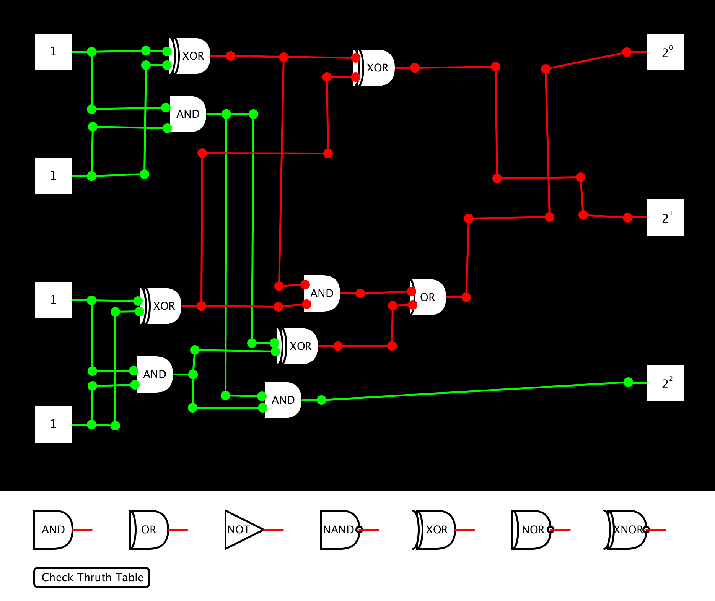 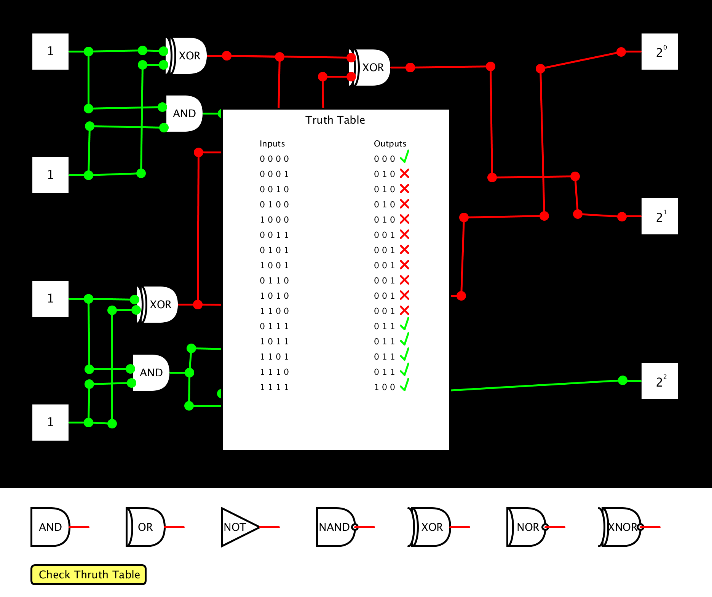

Left: Invalid Binary Adder Right: Corresponding Truth Table

Questions: rodgerb@miamioh.edu